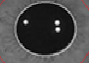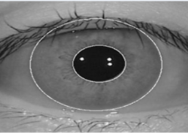

No Cataract

Cataract

Texture analysis using Support Vector Machine (SVM)

Feature set extraction including features

1. Contrast
2. Energy
3. Correlation
4. Homogeneity
5. Entropy
6. Standard Deviation

ROI

Implementation of Daugman’s Integro-Differential Operator

max(r,y0,x0)

=0.600

Localized Results

Localization

Pre-Processing and scaling

Image Acquisition